List of supplementary materials
Figure S1. ¹H NMR (500 MHz, CDCl₃) spectrum of metabolite 2
Figure S2. ¹³C NMR (125 MHz, CDCl₃) spectrum of metabolite 2
Figure S3. HSQC (CDCl₃) spectrum of metabolite 2
Figure S4. ¹H−¹H COSY (CDCl₃) spectrum of metabolite 2
Figure S5. HMBC (CDCl₃) spectrum of metabolite 2
Figure S6. HRESIMS spectrum of metabolite 2

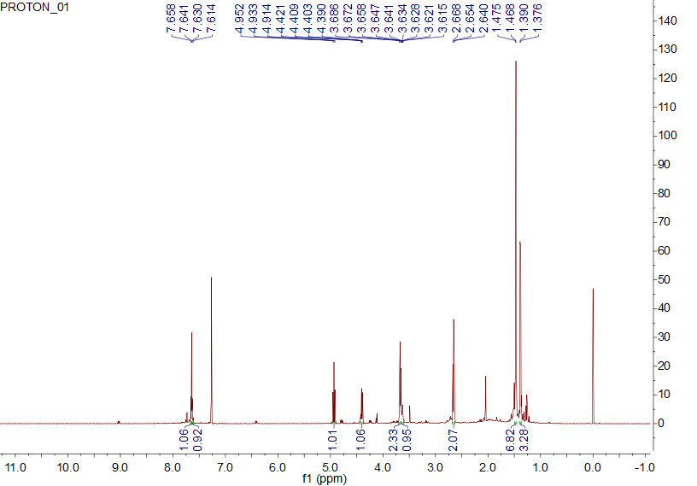
Figure S1. ¹H NMR (500 MHz, CDCl₃) spectrum of metabolite 2

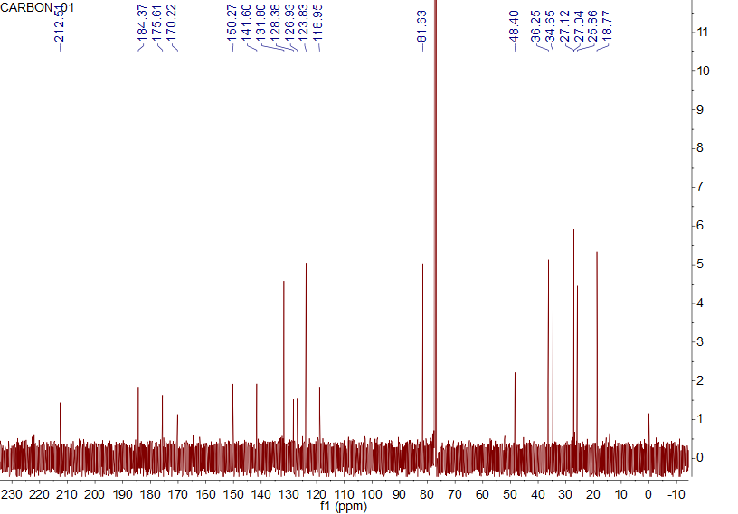
Figure S2. ¹³C NMR (125 MHz, CDCl₃) spectrum of metabolite 2
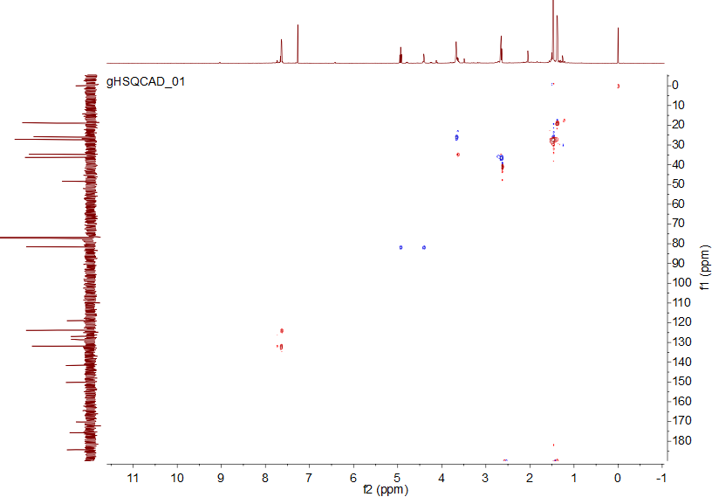
Figure S3. HSQC (CDCl₃) spectrum of metabolite 2

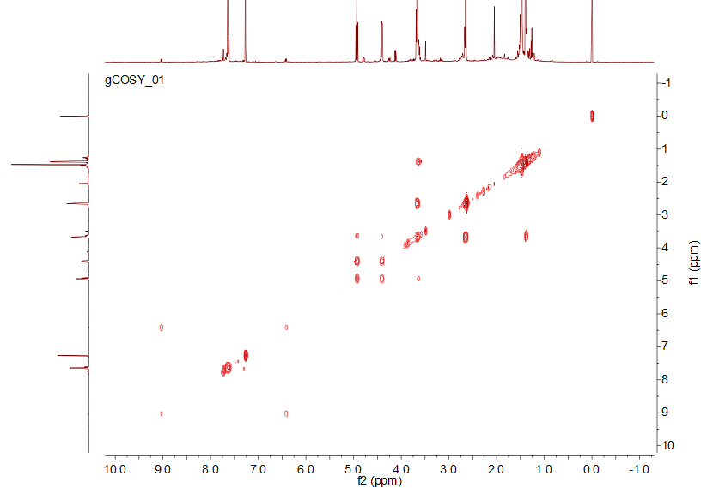
Figure S4. ¹H−¹H COSY (CDCl₃) spectrum of metabolite 2

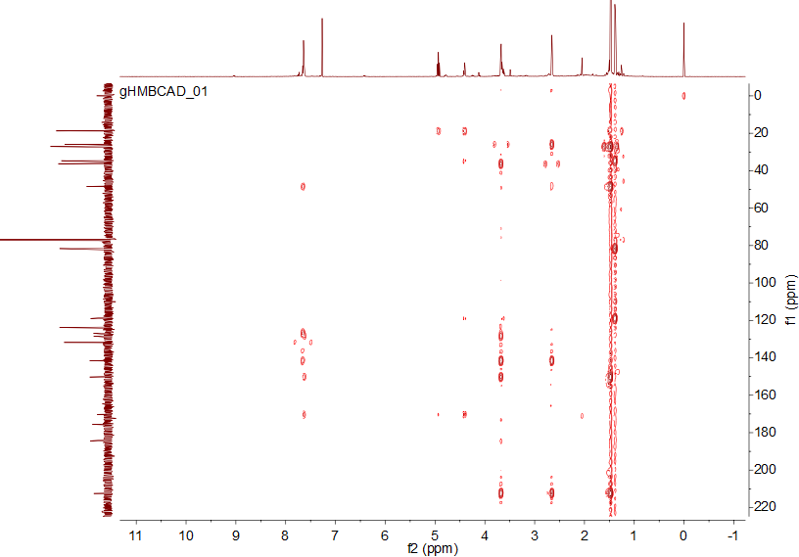
Figure S5. HMBC (CDCl₃) spectrum of metabolite 2

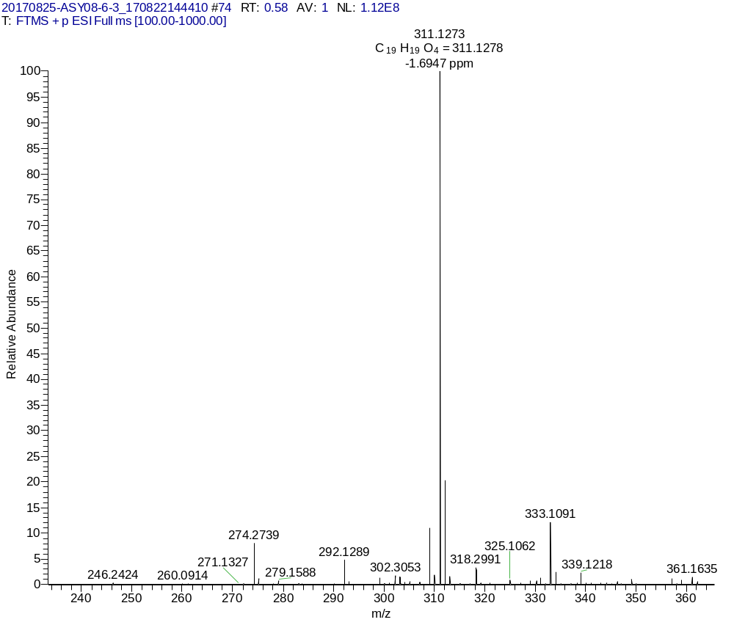
Figure S6. HRESIMS spectrum of metabolite 2

